**Introduction**

Computer-aided design (CAD) and engineering (CAE) applications often require dimensionality reduction of complex geometric shapes to make analysis and processing simpler. One important such reduction is the MidCurve - a one dimensional curve representation of 2D thin polygon shapes. This reduction has several benefits :

* Analysis: Simplification of analysis for thin-walled components
* Shape Processing: Improved pattern recognition and similarity matching
* Animation: Provides simpler structures to define movement
* Data Compression: Storage requirement goes down without losing important geometric features

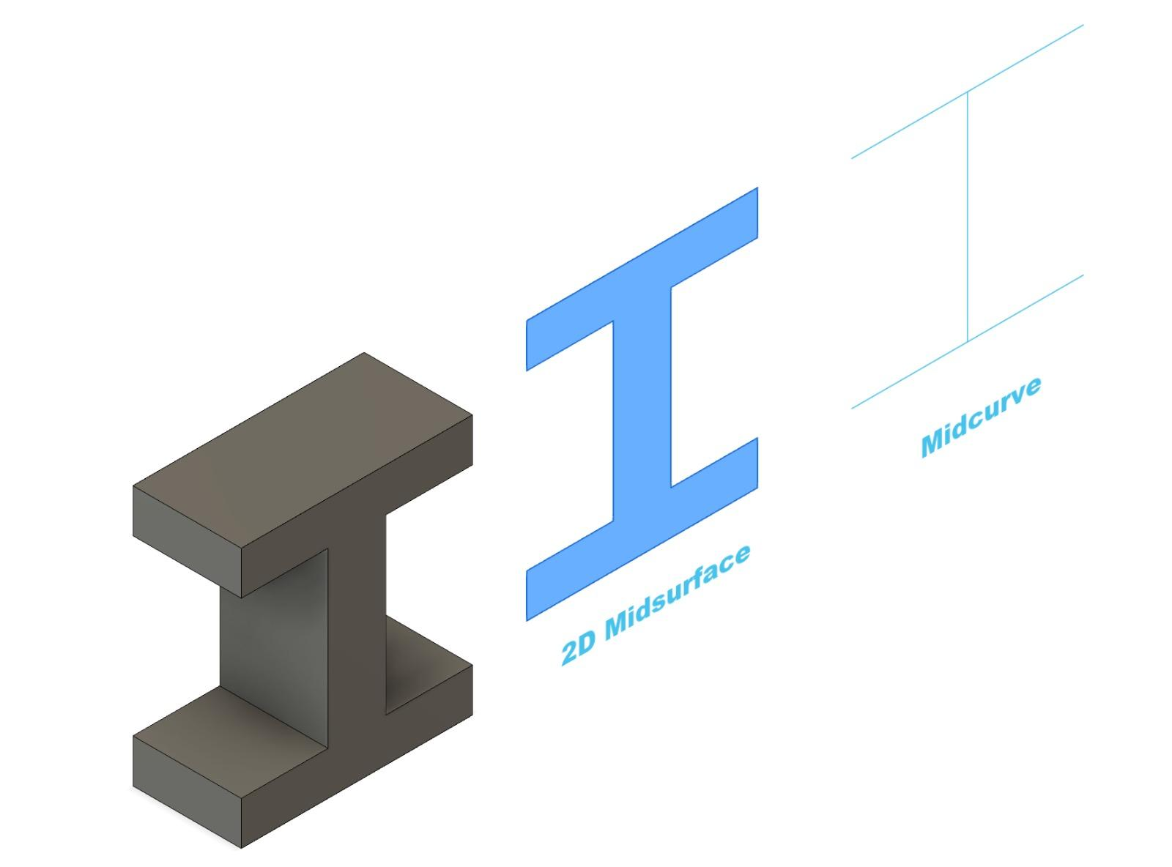

*Dimensional Reduction from 3 dimensional object to 1 dimensional Midcurve*

**1.2 Challenges in Midcurve Conversion**

Traditional Midcurve computation includes methods like Medial Axis Transform (MAT), Chordal Axis Transform (CAT), Straight Skeletons. These algorithms face some challenges:

* Often computationally expensive
* Any other drawbacks?

*Comparison of MAT, CAT and actual Midcurve Image*

**1.3 Midcurve NN Framework**

The original MidcurveNN framework introduced the method of tackling the problem of midcurve computation as a supervised learning problem. This implementation demonstrated feature learning and midcurve generation from input images. The MidCurveNN paper demonstrates that a *Simple Single Layer Encoder and Decoder* network can learn the dimension reduction function well. However, the original architecture also exhibited slightly noisy results in complex geometries. [What else can i write here?]

**1.4 Updated Architectural Approaches**

This paper presents two framework improvements to the original MidcurveNN architecture :

1. Dense Encoder Decoder Architecture :

* Deeper networks to enhance representation
* Skip connections to preserve information from encoder layers
* Early stopping for memory optimization

1. CNN based Architecture :

* Convolutional layers to preserve spatial feature
* Batch normalization for enhanced feature extraction
* Skip connections enhanced decoder
* Early stopping and learning rate plateau for memory optimization and to overcome learning rate stagnation

**1.5 Key Contributions**

This paper advances the current state-of-the-art in neural network-based Midcurve computation through:

* Developing two new architectural variants
* Comparative analysis of performance
* Enhanced training with adaptive learning rates

**2. Related Work**

Research on computing midcurves has been going on for decades. The approaches range from classic geometric methods to recent deep learning solutions.

**2.1 Classic Approaches**

Medial Axis Transform (MAT) : This approach is mathematically robust and can handle any shape. But it often creates unnecessary branches and produces results smaller than original faces.

Chordal Axis Transform (CAT) : This approach requires pre generation of mesh. This can be a challenging problem for complex 2D profiles.

*Images Showing Incorrect Results in these two methods*

**2.2 MidcurveNN: Foundation for Current Work**

The original MidcureNN paper introduced several key innovations :

* Converting Midcurve computation as an image-to-image transformation problem
* Using encoder-decoder architecture for dimension reduction
* Supervised learning with training data pair

This method was successful in capturing midcurves of 2D closed shapes. But it also had its limitations

* Simple architectural design with basic dense layers
* Limited Capability to capture spatial relations
* Lack of modern neural network optimizations

*Image Showing good results and also limitations*

### **2.3 Recent Developments**

Recent developments in deep learning suggest several improvements in the original MidcurveNN approach.

1. Dense Architecture : Modern dense neural networks with regularization and skip connections display good results in dimensional reduction tasks
2. CNN architecture : This approach shows superior capabilities in capturing spatial relations in image processing tasks
3. Hybrid approaches : Combination of both the above approaches shows promise in maintaining both fine and global features

**3. Proposed Architectural Improvements**

This section introduces two new framework enhancements to the original MidcurveNN architecture. The proposed frameworks use the recent advancements in deep learning to better capture the features essential for dimensionality reduction.

Both these frameworks have a common preprocessing pipeline. This normalizes the images into 128x128 pixels and scales the pixels to a [0,1] range. This ensures the network behaves consistently across varied inputs.

**3.1 Dense Encoder Decoder Architecture**

The first proposed enhancements uses a deep, fully-connected network structure expanding the representational capacity of the original MidcurveNN model. This model employs a gradual dimension reduction through multiple dense layers allowing better feature extraction.

The encoder pipeline gradually reduces the input dimension from 10,000 to 100, through intermediate representations of 2048 and 1024 neurons. This gradual reduction allows better preservation of features which might be lost in direct dimensional reduction. Each layer has ELU activation functions which have smoother gradients as compared to the traditional ReLU activations.

The decoder pipeline is symmetric to the encoder structure, and progressively expands the compressed representation to its original dimensions. This mirroring helps maintain geometric consistency between input and output. Finally the last layer employs a sigmoid activation function to produce the output.

We incorporated several training strategies to enhance training stability and convergence. The model is trained using an Adam Optimizer with a custom fine-tuned learning rate of 0.0001. The training is monitored through validation performance, with early-stopping to prevent over-fitting. We decided on a batch size of 32 to balance between computational efficiency and stability.

**3.2 CNN-based Architecture**

The second proposed architecture uses convolutional network structure which preserves spatial relationships in the inputs. This architecture tackles a fundamental drawback in fully connected networks: the inability to capture spatial hierarchies.

The CNN encoder is a feature extraction pipeline having four convolutional block layers. Each layer progressively reduces spatial dimension while increasing depth (32→64→128→256 filters). This allows the network to capture both the fine details and the overall structure. Each layer is followed by batch normalization. This improves the stability and normalization of features.

One of the key features in this architecture is the use of skip connections between encoder and decoder layers. These connections preserve information and gradients that might otherwise be lost or diluted by passing through multiple layers. The decoder pathway uses transposed convolutions for upsampling, with skip connections at each level to preserve spatial accuracy.

The training process incorporates dynamic learning rates using a plateau monitoring system. The learning rate is halved when loss stabilizes for five consecutive epochs. This approach, combined with early stopping ensures better results while preventing overfitting.

*Image for CNN and dense encoder decoder models*

**4. Experimental Setup**

This section summarizes the dataset preparation, training configurations and evaluation metrics.

**4.1 Dataset Preparation**

We have used the same dataset as the MidcurveNN research. The base shapes used for this research are 2D thin polygons, including english alphabets and other geometric shapes. These shapes are augmented using translations, rotations, mirroring and adding noise. This is done to improve the robustness and prevent overfitting. The input, output images are converted to 100x100 grayscale images. Input images contain thin polygon shapes and output images contain their polyline midcurves.

<Add “Conclusions” and “References” with all previous published papers, kaggle dataset, github repo and reference from earlier papers, if cited>